Jessica here is the link if the tables are too small.
https://www.cliffsnotes.com/study-guides/spanish/spanish-i/direct-and-indirect-object-pronouns/double-object-sentences
I have also highlighted the video clips.

Order of Object Pronouns

Overview
Objects pronouns (direct, indirect, and reflexive) are placed before the conjugated verbs they are associated with.
Le digo “te tengo que enseñar cómo se usa”, y me dice “pues ya lo probé” y no sabía nada.I tell her “I have to teach you how to use it”, and she says to me “well I already tried it” and she didn’t know anything.
https://www.coerll.utexas.edu/spintx/player/529/?start=114&end=119

However, with affirmative commands and non-conjugated verbs (e.g. infinitives or gerundives), the pronoun objects are attached to the end of the verb.
Dime qué cómoda te sientes al hablar el inglés.Tell me how comfortable you feel speaking English.
https://www.coerll.utexas.edu/spintx/player/493/?start=104&end=108

Direct and Indirect Object Pronouns Together
Sometimes there will be both a direct and an indirect object pronoun in the same sentence. The indirect object pronoun always precedes the direct object pronoun. As for their placement in relation to the verb, the general placement rules apply, so both indirect and direct object pronouns precede conjugated verbs (except with the affirmative imperative) or follow non-conjugated verbs, written as only one word in the latter case.
Había una oportunidad de trabajo en base a mi experiencia y no me lo dieron por mi inglés.There was a job opportunity and they didn’t give it to me because of my English.
https://www.coerll.utexas.edu/spintx/player/603/?start=47&end=53

Direct and Indirect Object Pronouns in Spanish
Quick Answer
Spanish direct object pronouns (pronombres de objeto directo ), such as lo , and Spanish indirect object pronouns (pronombres de objeto indirecto ), such as le , are used in place of nominal direct and indirect objects.
There are a few important rules that must be followed when using direct object pronouns and indirect object pronouns together.
But first, let's review Spanish direct and indirect object pronoun forms!

Spanish Direct Object Pronoun and Indirect Object Pronoun Forms
Direct Object Pronoun | Indirect Object Pronoun | English
me | me | me
te | te | you
lo , la | le | him, her, it, you
nos | nos | us
os | os | you (all)
los , las | les | them, you (all)
And now for the rules!

Maintaining Order
When direct and indirect object pronouns are used together in a sentence, the indirect object pronoun comes before the direct object pronoun.
Marcos nos trajo la comida a nosotros.
Marcos brought the food to us.

Marcos nos la trajo.
Marcos brought it to us.

Mi madre está comprándome una pizza.
My mom is buying me a pizza.

Mi madre está comprándomela.
My mom is buying it for me.

Dame el control remoto.
Give me the remote control.

Dámelo.
Give it to me.

No quiero decirte la verdad.
I don’t want to tell you the truth.

No quiero decírtela.
I don’t want to tell it to you.

Notice that when object pronouns are attached to a verb, it's often necessary to add an accent in order to preserve the natural stress of the verb.

Changing Le to Se
The indirect object pronouns le and les change to se when followed by the direct object pronouns lo, la, los and las.
le/les -> se before lo, la, los, las
Le digo el cuento a María.
I tell the story to María.

Se lo digo.
I tell it to her.

Mi abuelo les compró los regalos a los niños.
My grandfather bought gifts for the children.

Mi abuelo se los compró.
My grandfather bought them for them.

Negatives
When a sentence with object pronouns is negative, the negative word (for example, no or nunca ) directly precedes any object pronouns.
No te la tengo.
I don’t have it for you.

Ella nunca compra helado para sus hijos. Ella nunca se lo compra.
She never buys ice cream for her kids. She never buys it for them.

Double Object Sentences
Direct object pronouns and indirect object pronouns are placed in front of the verb. Since it is common to have both an indirect and direct object pronoun in a sentence, they will both be directly in front of the verb. In such sentences, the indirect object pronoun always precedes the direct object pronoun.

When there are direct and indirect object pronouns in the same sentence, follow the formula: the I.O.P. (Indirect Object Pronoun) then the D.O.P. (Direct Object Pronoun. Both precede the conjugated verb.

Subject + I.O.P + D.O.P + verb + rest of sentence.
In the following examples, the first sentence establishes what the actual direct object of the sentence is, and the second sentence uses a direct object pronoun to replace it. The indirect object is in bold and the direct object is underlined to help you visualize what noun changes into what pronoun and where they are placed in the sentence. Notice that once you change the direct object to a pronoun, you must remove the direct object pronoun based on the formula above. These techniques will help you understand object pronouns.

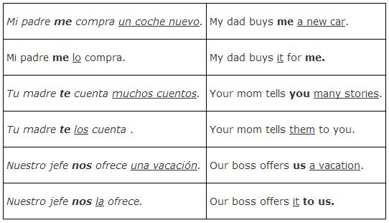

The use of se

When two object pronouns beginning with the letter l (le, les, la, lo, las, los) are used together, the first pronoun, which is always the I.O.P., changes to se. The following examples tackle this situation. The indirect object is in bold and the direct object is underlined to help you visualize what noun changes into what pronoun and where they are placed in the sentence.

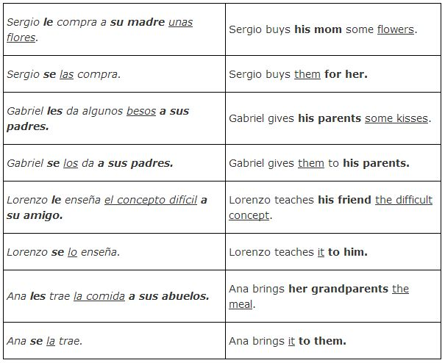
Here's another way to think of it: le and les change to se when placed before lo, la, los, or las.

Adding two object pronouns to verbs
Object pronouns can be attached either to the end of a present participle form of the verb or to the end of an infinitive form of the verb, as well as placed in front of a conjugated form of the verb. If you are using two object pronouns, they will be together wherever you choose to place them.
Adding two pronouns to the end of an infinitive messes up the natural stress and requires you to add an accent mark to the vowel before the final – r of the infinitive. You can add one pronoun to an infinitive without adding an accent, but you must add a written accent if you attach two object pronouns to the end of an infinitive. For example:
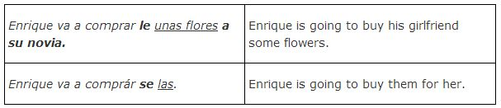You learned earlier that you must add an accent mark to a present participle if even one pronoun is added. Since a present participle ends in a vowel, even one pronoun added to the end will mess up the natural stress. So you must add an accent to the vowel before the – ndo of the gerund if you add either one or two pronouns.

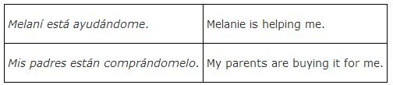

There is always a conjugated verb in every sentence, so you can always put both object pronouns in front of the conjugated form of the verb. Do not, however, place one pronoun in front of the conjugated form of the verb and attach the other object pronoun to the end of an infinitive or present participle.

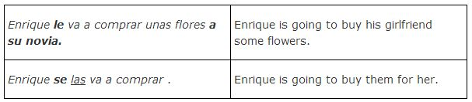

Choose the appropriate answer based on each question.

1. Which are INCORRECT couplings of double object pronouns?
Te lo
Me te
Lo se
Se las
Le las

Lo me

2. When placing an indirect and direct object pronoun in a sentence, the indirect is placed first.
True
False

3. Choose ALL correct locations for placement of double O.P.
In front of unconjugated verb
In front of infinitive
In front of conjugated verb.
Attached to end of past participle
Attached to beginning of present participle
Attached to the end of present participle
Attached to infinitive

4. Double object pronouns can go in the same three spots as single object pronouns
True
False

5. Where is the word properly accented?
Mandarmeló
Mandármelo
Mandarmélo
No need for accent

Choose the option for each sentence that best shows the use of double objects.

Francisco le manda el libro a Nicolás. =
- Francisco me lo manda.
- Francisco se lo manda.
- Francisco se los manda.
Mi padre me compra la revista. =
- Mi padre me la compra.
- Mi padre se lo compra.
- Mi padre te lo compra.
Los hermanos nos mandan el paquete. =
- Los hermanos se lo mandan.
- Los hermanos nos la mandan.
- Los hermanos nos lo mandan.

Lucía me va a tirar la pelota a mí. =
- Lucía me lo va a tirar.
- Lucía nos la va a tirar.
- Lucía va a tirármela.
Verónica le está enviando las cartas a Josefa. =
- Verónica me las está enviando.
- Verónica se las está enviando.
- Verónica te la está enviando.
Enrique te pasa la sal a ti. =
- Enrique se la pasa.
- Enrique te la pasa.
- Enrique se lo pasa.
Hilda nos escribe la tarjeta (a nosotros.) =
- Hilda nos la escribe.
- Hilda se la escribe.
- Hilda te la escribe.
Su papá os da los cuadernos. =
- Su papá se lo da.
- Su papá nos los da.
- Su papá os los da.
El profesor le muestra las apuntes a Inés. =
- El profesor se la muestra.
- El profesor me lo muestra.
- El profesor se los muestra.
José le quiere entregar la tarea al señor Ibáñez. =
- José quiere entregársela.
- José quiere entregármela.
- José quiere entregárnoslo.

Given a sentence, choose the correct indirect and direct object pronoun combination for the indirect and direct object pronouns given.

Maria ___ ___ canta a ellas.(i.o. les; d.o. la)
- 1
la les
- 2
les la
- 3
la se
- 4
se la
- 5
se les

Felipe y Ramón ___ ___ robaron. ( i.o. nos; d.o. lo)
- 1
lo se
- 2
se lo
- 3
lo nos
- 4
lo las
- 5
nos lo
Diego ___ ___ debe explicar (i.o. me ; d.o. lo)
- 1
lo se
- 2
me lo
STREAK x3
- 3
le me
- 4
se lo
- 5
lo me
No ___ ___ quiero devolver. (i.o. te ; d.o. las)
- 1
las te
- 2
se las
- 3
te las
STREAK x4
- 4
las se
- 5
se te
(Vosotros) ___ ___ pusisteis en la cartera. (i.o. les d.o. los)
- 1
les los
- 2
los se
- 3
se los
STREAK x5
- 4
los se
- 5
se les
(Ella) ___ ___ entrega. (; i.o. les ; d.o. los)
- 1
los las
- 2
se los
STREAK x6
- 3
los les
- 4
les los
- 5
los se
Juan y Paco ___ ___ dan. (i.o. te; d.o. lo)
- 1
se lo
- 2
te lo
STREAK x7
- 3
lo te
- 4
se te
- 5
te se
Víctor ___ ___ contó. (i.o. me; d.o. lo)
- 1
me lo
STREAK x8
- 2
se me
- 3
lo me
- 4
lo se
- 5
se lo
El regalo ___ ___ dio a nuestro vecino. (i.o. le; d.o. lo)
- 1
le lo
- 2
lo se
- 3
los le
- 4
lo le
- 5
se lo
Lisa ___ ___ cocina. (i.o. le; d.o. lo)
- 1
le lo
- 2
lo le
- 3
se le
- 4
se lo
STREAK x10
- 5
lo se

(Él) ___ ___ dio. (i.o. le; d.o. la)
- 1
la se
- 2
se la
STREAK x11
- 3
la te
- 4
la le
- 5
le la
(Ellas) ___ ___ dan. (i.o, me; d.o. los)
- 1
los se
- 2
los me
- 3
me los
STREAK x12
- 4
se me
- 5
se los
Sé que ___ ___ contaste. (i.o. les; d.o. lo)
- 1
lo se
- 2
le se
- 3
se lo
STREAK x13
- 4
les lo
- 5
se le
Raúl me exigió que ___ ___ entregue. (i.o. les; d.o. las)
- 1
se las
STREAK x14
- 2
las se
- 3
las les
- 4
les las
- 5
se les
Yo) ___ ___ traigo pronto. (i.o. les ; d.o. lo)
- 1
se lo
STREAK x15
- 2
les lo
- 3
lo les
- 4
lo se
- 5
se les
No quiero decir___ ___ (i.o. les d.o. lo)
- 1
se le
- 2
sela
- 3
le se
- 4
selo
- 5
lo se
Alguien ___ ___ robó. (i.o me; d.o. lo)
- 1
lo se
- 2
me lo
- 3
se me
- 4
lo me
- 5
se lo
___ ___ voy a mandar por carta. (i.o. les; d.o. la)
- 1
les la
- 2
se la
- 3
la les
- 4
la se
- 5
se les
(Ellos) ___ ___ cuentan a carcajadas (loud laugheter). (i.o me; d.o. lo)
- 1
se lo
- 2
me lo
STREAK x3
- 3
lo me
- 4
se me
- 5
me se
Vamos a comprar___ ___ . (i.o. les; d.o. la)
- 1
la se
- 2
les la
- 3
sela
- 4
selo
- 5
la les
___ ___ devuelvo mañana. (i.o. os; d.o. los)
- 1
los os
- 2
os los
- 3
se los
- 4
los se
- 5
se os

- Nosotros les decimos la verdad. = Nosotros SE LA
1.
decimos.
- Yo siempre le doy amor. = Yo siempre SE LO
2.
doy.
- Tú le mandas regalos. = Tú SE LOS
3.
mandas.
- Yo te doy un regalo. = Yo TE LO
4.
doy.
- Ella nunca me presta su coche. = Ella nunca ME LO
5.
presta.
- Yo les hablo español. = Yo SE LO
6.
hablo.
- Felipe siempre me sirve chiles. = Felipe siempre ME LOS
7.
sirve.
- Tío Antonio nos regala muchas bufandas. = Tío Antonio NOS LAS
8.
regala.
- Yo te presto mis lentes. = Yo TE LOS
9.
presto.
- Yo te mido la manga. = Yo TE LA
10.
mido.

Complete the sentence with the correct double object pronouns.
- ¿Quieres darle a tu novio un reloj para su cumpleaños? Sí, quiero dár____.
The following answer is acceptable:
selo
- ¿Necesita crear el cuadro para ustedes Pablo? Sí necesita creár____.
The following answer is acceptable:
noslo
- Nosotros decimos el secreto a ti. Nosotros _____ decimos.
The following answer is acceptable:
te lo
- ¿Prepararon uds. la cena para tu familia? Sí _____ preparamos.
The following answer is acceptable:
se la
- ¿Tienen que hacer Uds. el diagrama para los profesores? Si tenemos que hacér_____.
The following answer is acceptable:
selo
- Mi amigo me trajo las llaves. Mi amigo _____ trajo.
The following answer is acceptable:
me las
- ¿Completaste la tarea para mi? Sí ______ completé.
The following answer is acceptable:
te la
- ¿Te di los discos compactos? Sí, _____ diste.
The following answer is acceptable:
me los
- Pedimos los postres a la camarera. ______ pedimos.
The following answer is acceptable:
se los
- Mi familia mandó las camisetas a nosotros. Mi familia _____ mandó.
The following answer is acceptable:
nos las
Jessica: Can you input two blanks for the ones that go in front and only one blank on the end of the verbs where they appear together at the end?

Fill in the blank(s) with the correct forms of the indirect and direct object pronouns. Remember the indirect object pronoun always precedes the direct object pronoun.
1. Les escribo unas cartas románticas a Keanu y a Antonio.
___ ___ escribo. Se las

2. ¿Puedes pasarme el suéter y la gorra?
¿ ___ ___ puedes pasar. Me los

- Le estoy diciendo la verdad a la policía.
Se la estoy diciendo.

- Tienes que mostrarme las fotos.
Tienes que mostrármelas.

- Me compró un anillo de esmeraldas (emeralds).
Me lo compró.

6. Me mandaban un paquete de caramelos cada año.
Me lo mandaban.
7. Mauricio me dio las flores a mí.
Me las dio.
8. La estudiante nueva le sacó los apuntes a ella.
Se los sacó.
9. ¡Vamos a comprarle un bote! Se lo vamos a comprar.
¡Vamos a comprárselo!
JESSICA THIS CAN BE A SUBMISSION ACTIVITY, NO NEED TO INPUT AN ANSWER, JUST THE SENTENCES.
Replace the indirect objects and direct object for indirect object pronouns and direct object pronouns.
Example: Le traigo la lista al jefe.
Answer: Se la traigo.
1. Le doy el papel al director.
Se lo doy.
2. Le doy los documentos a usted.
Se los doy
3. Le regalamos el reloj a mi madre.
Se lo regalamos.
4. Me regalan un libro a mí.
Me lo regalan.
5. María me pide la tortilla a mí.
Me la pide.
6. Nos piden dinero a nosotros.
Nos lo piden.
7. No te traemos el coche a ti.
No te lo traemos.
8. Te traigo fotos a ti.
Te las traigo.
9. Nos hacen preguntas a nosotros.
Nos las hacen.
10. Raquel no le da un regalo a Ernesto.
No se lo da.

JESSICA: CAN YOU PLEASE LINK OUT TO THIS ACTIVITY?
https://www.sporcle.com/games/SraLev/spanish-double-object-pronouns1

